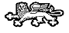 | 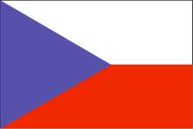 Czech and Slovak Club of Greater Kansas City 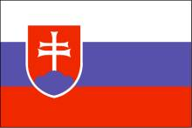

If you are of Czech or Slovak descent, or are simply interested in the culture, customs, and history of the Republics, please fill out the form below and return. We welcome and invite you to become a member and join in our activities.

Name: ................................................................................................................................
Address: .............................................................................................................................
Phone: ................................................................................................................................
E-mail: ...............................................................................................................................

Annual dues, please check :
__ Single $15
__ Family $20

__ I would like to join and begin receiving the quarterly newsletter.
__ I have information to share with the group.
__ I am interested in becoming a club officer or helping with an event.

Comments:

Please enclose a check made payable to the Czech and Slovak Club of Greater Kansas City and mail to: Terry Smitka, 1205 Wellington Way, Liberty, Mo. 64068 - tsmitka@rwbaird.com

Please indicate if you have an interest and/or would participate in any of the following:

1. Viewing Czech/Slovak Movies ____ 7. Czech/Slovak cooking classes ____
2. Czech/Slovak genealogy ____ 8. Czech/Slovak language classes ____
3. Czech/Slovak beer or wine tasting ____ 9. Any other ideas or suggestions? ____
4. Cultural/political discussions ____ _______________________________
5. Volunteering for club programs or committees ____
6. Travel/tourist information about Czech/Slovak Republics ____

